**Question Results**

Score 0 of 1

**Question:**

**See the diagrams. You want to merge rows from the PORT_INVENTORY table into the SHIP_INVENTORY table. You start with the following SQL statement:**

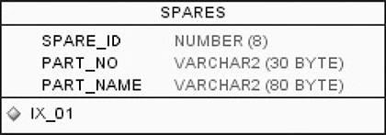

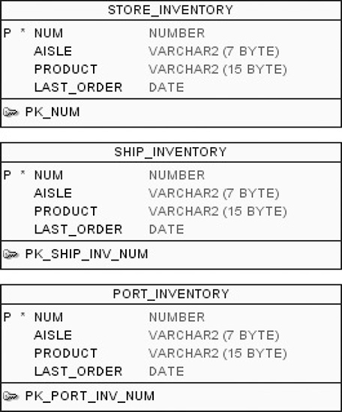

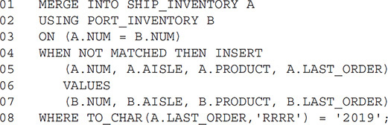

**What will this SQL statement do?**

**Response:**

|  |  |
| --- | --- |
|  | It will fail with a syntax error because you must have an ELSE clause. |
| Wrong | It will add rows from PORT_INVENTORY to SHIP_INVENTORY that do not already exist in SHIP_INVENTORY, limited to LAST_ORDER values from the year 2019. |
|  | It will add rows from PORT_INVENTORY to SHIP_INVENTORY that do not already exist in SHIP_INVENTORY, regardless of the value for LAST_ORDER. |
| Should have chosen | It will fail with a syntax error because you cannot reference the target table (SHIP_INVENTORY) in the WHERE clause in line 8. |

Score 1 of 1

**Question:**

**Which of the following can be said of the CASE statement?**

**Response:**

|  |  |
| --- | --- |
|  | Its END keyword is optional. |
|  | It uses the keyword IF. |
|  | It converts text to uppercase. |
| Correct | It uses the keyword THEN. |

Score 0 of 1

**Question:**

**Which of the following statements is true about HAVING?**  
(Choose two.)

**Response:**

|  |  |
| --- | --- |
| Wrong | It cannot reference an expression unless that expression is first referenced in the GROUP BY clause. |
| Should have chosen | It must occur after the WHERE clause. |
| Should have chosen | It can be used only in the SELECT statement. |
| Wrong | It must occur after the GROUP BY clause. |

Score 0 of 1

**Question:**

**The ORDER BY clause can be included in a SELECT with set operators if:**

**Response:**

|  |  |
| --- | --- |
| Should have chosen | It follows the final SELECT statement. |
|  | It is used in each SELECT statement and its ORDER BY expressions match in data type. |
|  | The ORDER BY clause cannot be used in a SELECT with set operators. |
| Wrong | It follows the first SELECT statement. |

Score 0 of 1

**Question:**

**Which three tasks can be performed using SQL functions built into Oracle Database?**

(Choose three.)

**Response:**

|  |  |
| --- | --- |
| Wrong | Combining more than two columns or expressions into a single column in the output |
| Correct | Displaying a date in a nondefault format |
| Should have chosen | Substituting a character string in a text expression with a specified string |
| Correct | Finding the number of characters in an expression |

Score 0 of 1

**Question:**

**Review this SQL statement: SELECT LASTNAME FROM CUSTOMERS WHERE LASTNAME = SOUNDEX('Franklin'); What is a possible result for the query?**

**Response:**

|  |  |
| --- | --- |
| Wrong | Phrankline |
|  | Franklyn |
| Should have chosen | None of the above |
|  | Ellison |

Score 1 of 1

**Question:**

**View the Exhibit and examine the description of the DEPARTMENTS and EMPLOYEES tables.**

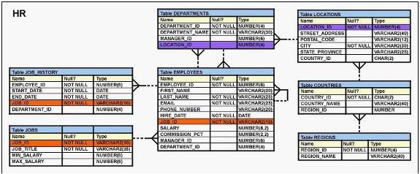

**To retrieve data for all the employees for their EMPLOYEE_ID, FIRST_NAME, and DEPARTMENT NAME, the following SQL statement was written:**

SELECT employee_id, first_name, department_name  
FROM employees  
NATURAL JOIN departments;

**The desired output is not obtained after executing the above SQL statement. What could be the reason for this?**

**Response:**

|  |  |
| --- | --- |
|  | The DEPARTMENTS table is not used before the EMPLOYEES table in the FROM clause. |
| Correct | The EMPLOYEES and DEPARTMENTS tables have more than one column with the same column name and data type. |
|  | The table prefix is missing for the column names in the SELECT clause. |
|  | The NATURAL JOIN clause is missing the USING clause. |

Score 1 of 1

**Question:**

**Review the following SQL statement:**

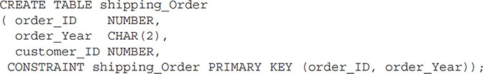

**Assume there is no table already called SHIPPING_ORDER in the database. What will be the result of an attempt to execute the preceding SQL statement?**

**Response:**

|  |  |
| --- | --- |
| Correct | The statement will succeed: the table will be created, and the primary key will also be created. |
|  | The statement will fail because the data type for ORDER_YEAR is a CHAR, and CHAR data types aren’t allowed in a PRIMARY KEY constraint. |
|  | The statement will fail because there is no precision for the ORDER_ID column’s data type. |
|  | The table will be created, but the primary key constraint will not be created because the name does not include the _PK suffix. |

Score 1 of 1

**Question:**

**Evaluate the following SQL statement:**

SQL> SELECT cust_id, cust_last_name "Last Name" FROM customers  
WHERE country_id = 10  
UNION  
SELECT cust_id CUST_NO, cust_last_name FROM customers  
WHERE country_id = 30;

**Which ORDER BY clause are valid for the above query?**

(Choose all that apply.)

**Response:**

|  |  |
| --- | --- |
| Correct | ORDER BY 2,1 |
|  | ORDER BY CUST_NO |
|  | ORDER BY "CUST_NO" |
| Correct | ORDER BY "Last Name" |
| Correct | ORDER BY 2,cust_id |

Score 0 of 1

**Question:**

**Consider the following query, its output, and a subsequent query:**

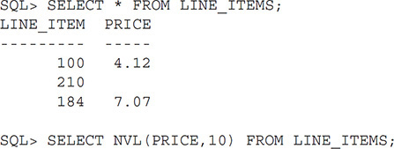

**What is true of the final query shown previously?**

**Response:**

|  |  |
| --- | --- |
| Should have chosen | It will return three rows, but it will not change the price for line items 100 and 184. |
| Wrong | It will return no rows because there is no PRICE of 10. |
|  | It will return “no rows found” because there is no PRICE of 10. |
|  | It will return only the row where LINE_ITEM is 210. |

Score 1 of 1

**Question:**

**Examine the structure of the members table:**

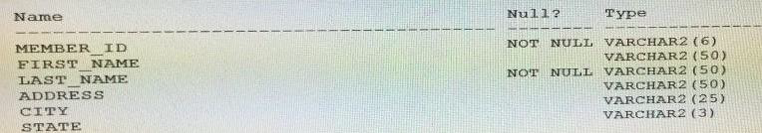

**You want to display details of all members who reside in states starting with the letter A followed by exactly one character. Which SQL statement must you execute?**

**Response:**

|  |  |
| --- | --- |
| Correct | SELECT * FROM MEMBERS WHERE state LIKE 'A_'; |
|  | SELECT * FROM MEMBERS WHERE state LIKE '%A_' ; |
|  | SELECT * FROM MEMBERS WHERE state LIKE 'A_%'; |
|  | SELECT * FROM MEMBERS WHERE state LIKE 'A%'; |

Score 0 of 1

**Question:**

**The LEAD function returns data from:**

**Response:**

|  |  |
| --- | --- |
| Should have chosen | The row specified by the LEAD function’s offset |
|  | A row following the current row as specified by the SELECT statement’s ORDER BY clause |
| Wrong | A row prior to the current row as specified by the LEAD function’s ORDER BY clause |
|  | The LAG function’s window’s specified column |

Score 1 of 1

**Question:**

**Review the following SQL statements:**

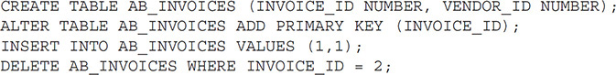

**Which of the following best describes the results of attempting to execute the DELETE statement?**

**Response:**

|  |  |
| --- | --- |
|  | The DELETE statement will fail because it is missing a column list between the word DELETE and the name of the table AB_INVOICES. |
|  | None of the above. |
| Correct | The DELETE statement will execute, but no rows in the table will be removed. |
|  | The DELETE statement will produce a syntax error because it is referencing a row that does not exist in the database. |

Score 1 of 1

**Question:**

**Which of the following is true of character functions?**

**Response:**

|  |  |
| --- | --- |
|  | They generally have the letters CHAR somewhere in the function name. |
| Correct | They are generally used to process text data. |
|  | They always accept characters as parameters and nothing else. |
|  | They always return a character value. |

Score 0 of 1

**Question:**

**Review the PORTS and SHIPS tables shown. Then review the following SQL code:**

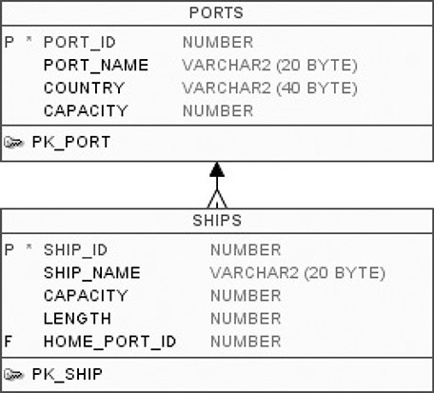

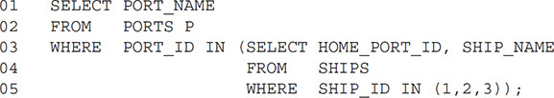

**Which of the following is true of this statement?**

**Response:**

|  |  |
| --- | --- |
|  | The statement will fail with a syntax error because of line 5. |
|  | None of the above. |
| Wrong | Whether the statement fails depends on how many rows are returned by the subquery in lines 3 through 5. |
| Should have chosen | The statement will fail with a syntax error because of line 3. |

Score 1 of 1

**Question:**

**A table alias:**  
(Choose two.)

**Response:**

|  |  |
| --- | --- |
| Correct | Exists only for the SQL statement that declared it. |
| Correct | Can be used to clear up ambiguity in the query. |
|  | Renames a table in the database so that future joins can use the new name. |
|  | Is the same thing as a database object synonym. |

Score 0 of 1

**Question:**

**One place to get a master list of all the views that form the data dictionary is:**

**Response:**

|  |  |
| --- | --- |
|  | DATA_DICTIONARY |
| Should have chosen | DICTIONARY |
| Wrong | USER_CATALOG |
|  | CATALOG |

Score 0 of 1

**Question:**

**In which three situations does a transaction complete?**

**Response:**

|  |  |
| --- | --- |
| Wrong | when a DELETEstatement is executed |
| Should have chosen | when a ROLLBACKcommand is executed |
|  | when a PL/SQL anonymous block is executed |
| Correct | when a data definition language (DDL) statement is executed |
| Correct | when a TRUNCATEstatement is executed after the pending transaction |

Score 0 of 1

**Question:**

**When transforming an ERD into a relational database, you often use an entity to build a database’s:**

**Response:**

|  |  |
| --- | --- |
| Should have chosen | Table |
| Wrong | Relationship |
|  | Column |
|  | Attribute |

Score 1 of 1

**Question:**

**Review the illustration and the following SQL code:**

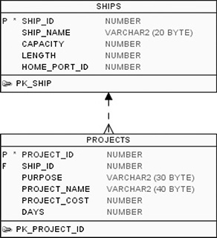

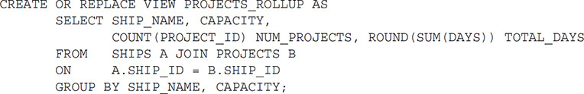

**What can be said of this code?**

**Response:**

|  |  |
| --- | --- |
|  | The attempt to create the view will fail because you cannot create a VIEW with a SELECT statement that uses a GROUP BY clause. |
|  | The attempt to create the view will fail because you cannot create a VIEW with a SELECT statement that is a join. |
| Correct | After the view is created, a valid SELECT statement will work on the PROJECTS_ROLLUP view, but an INSERT will not. |
|  | After the view is created, a valid SELECT and valid INSERT statement will work on the PROJECTS_ROLLUP view. |

Score 0 of 1

**Question:**

**Review the illustration and the following SQL code:**

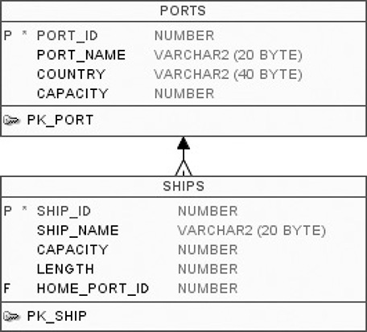

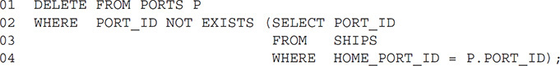

**The code is attempting to delete any row in the PORTS table that is not a home port for any ship in the SHIPS table, as indicated by the HOME_PORT_ID column.**

**In other words, only keep the PORTS rows that are currently the HOME_PORT_ID value for a ship in the SHIPS table; get rid of all other PORT rows. That’s the intent of the SQL statement.**

**What will result from an attempt to execute the preceding SQL statement?**

**Response:**

|  |  |
| --- | --- |
|  | It will fail because of an execution error in the subquery. |
| Wrong | It will execute successfully and perform as intended. |
| Should have chosen | It will fail because of a syntax error on line 2. |
|  | It will fail because of a syntax error on line 4. |

Score 0 of 1

**Question:**

**Which three statements are true regarding the WHERE and HAVING clauses in a SQL statement?**  
(Choose three.)

**Response:**

|  |  |
| --- | --- |
| Wrong | WHERE and HAVING clauses cannot be used together in a SQL statement. |
|  | The HAVING clause conditions can use aliases for the columns. |
| Correct | The HAVING clause conditions can have aggregate functions. |
| Should have chosen | The HAVING clause is used to exclude one or more aggregated results after grouping data. |
| Correct | The WHERE clause is used to exclude rows before the grouping of data. |

Score 1 of 1

**Question:**

**Review this code:**

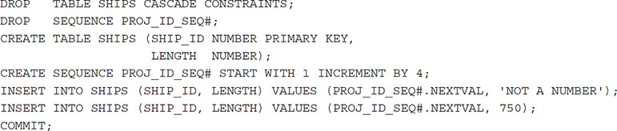

**Note that the first INSERT statement is attempting to enter a string literal of 'NOT A NUMBER' into a column declared with a numeric data type. Given that, what will be the result of these SQL statements?**

**Response:**

|  |  |
| --- | --- |
|  | One row added to the SHIPS table, with a SHIP_ID value of 1. |
|  | Two rows added to the SHIPS table. The first SHIP_ID is 1; the second is 5. |
|  | Two rows added to the SHIPS table. The first SHIP_ID is NULL; the second is 5. |
| Correct | One row added to the SHIPS table, with a SHIP_ID value of 5. |

Score 1 of 1

**Question:**

**You have a single database, with only one schema. The following four objects exist in the database:**  
– A TABLE named PRODUCT_CATALOG  
– A TABLE named ADS  
– A USER named PRODUCT_CATALOG  
– A VIEW named CONFERENCE_SCHEDULE

**How many of the four objects are owned by the schema?**

**Response:**

|  |  |
| --- | --- |
|  | 0 |
|  | 2 |
| Correct | 3 |
|  | 4 |

Score 1 of 1

**Question:**

**Which statement is true about an inner join specified in the WHERE clause of a query?**

**Response:**

|  |  |
| --- | --- |
|  | It requires the column names to be the same in all tables used for the join conditions. |
|  | It must have primary-key and foreign-key constraints defined on the columns used in the join condition. |
| Correct | It is applicable for equijoin and nonequijoin conditions. |
|  | It is applicable for only equijoin conditions. |

Score 0 of 1

**Question:**

**You need to display the date 11-oct-2017 in words as 'Eleventh of October, Two Thousand Seventeen'.**

**Which SQL statement would give the required result?**

**Response:**

|  |  |
| --- | --- |
|  | SELECT TO_CHAR ('11-oct-2017', 'fmDdspth or Month, Year') FROM DUAL; |
|  | SELECT TO_DATE (TO_CHAR ('11-oct-2017'), 'fmDdspth 'of Month, Year')) FROM DUAL; |
| Wrong | SELECT TO_CHAR (TO_DATE ('11-oct-2017'), 'fmDdthsp of Month, Year') FROM DUAL; |
| Should have chosen | SELECT TO_CHAR (TO_DATE ('11-oct-2017'), 'fmDdspth "of" Month, Year') FROM DUAL; |

Score 1 of 1

**Question:**

**Review the illustration and then review the following SQL statement:**

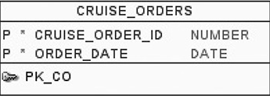

**https://www.dbexam.com/files/dbexam/download/1Z0-071_ch7_5.png**

**What will result from an attempt to execute this SQL statement on the CRUISE_ORDERS table?**

**Response:**

|  |  |
| --- | --- |
|  | It will fail with an execution error because you cannot use the MIN function on a DATE data type. |
| Correct | It will execute and perform as intended. |
|  | It will fail with an execution error if the table contains only one row. |
|  | It will fail with an execution error because you cannot use the AVG function on a PRIMARY KEY column. |

Score 1 of 1

**Question:**

**Which three statements are true regarding subqueries?**

**Response:**

|  |  |
| --- | --- |
| Correct | Multiple columns or expressions can be compared between the main query and subquery. |
|  | Main query and subquery must get data from the same tables |
| Correct | Subqueries can contain GROUP BY and ORDER BY clauses |
|  | Subqueries can contain ORDER BY but not the GROUP BY clause. |
| Correct | Main query and subquery can get data from different tables. |
|  | Only one column or expression can be compared between the main query and subquery. |

Score 1 of 1

**Question:**

**When is a query considered a multirow subquery?**  
(Choose the best answer.)

**Response:**

|  |  |
| --- | --- |
|  | All of the above |
|  | If it returns numeric data, regardless of the number of rows of data it returns |
|  | If it may or may not return multiple rows, as determined by its WHERE clause |
| Correct | If it returns multiple rows at the time of execution |

Score 0 of 1

**Question:**

**Which of the following problems can be solved with a subquery?**  
(Choose the two best answers.)

**Response:**

|  |  |
| --- | --- |
| Correct | You are tasked with determining which divisions in a corporation earned sales last year that were less than the average sales for all divisions in the prior year. |
|  | You are tasked with creating a sequence. |
| Wrong | You are tasked with determining the minimum sales for every division in a multinational corporation. |
| Should have chosen | You are tasked with creating a view. |

Score 0 of 1

**Question:**

**Examine the data in the CUST_NAME column of the CUSTOMERS table.**

CUST_NAME ------------------------  
Renske Ladwig Jason Mallin  
Samuel McCain Allan MCEwen Irene Mikkilineni Julia Nayer

**You need to display customers' second names where the second name starts with "Mc" or "MC." Which query gives the required output?**

**Response:**

|  |  |
| --- | --- |
| Should have chosen | SELECT SUBSTR(cust_name, INSTR(cust_name,' ')+1) FROM customers  WHERE INITCAP(SUBSTR(cust_name, INSTR(cust_name,' ')+1)) LIKE 'Mc%'; |
|  | SELECT SUBSTR(cust_name, INSTR(cust_name,' ')+1) FROM customers  WHERE INITCAP(SUBSTR(cust_name, INSTR(cust_name,' ')+1)) = INITCAP('MC%'); |
| Wrong | SELECT SUBSTR(cust_name, INSTR(cust_name,' ')+1) FROM customers  WHERE SUBSTR(cust_name, INSTR(cust_name,' ')+1) LIKE INITCAP('MC%'); |
|  | SELECT SUBSTR(cust_name, INSTR(cust_name,' ')+1) FROM customers  WHERE INITCAP(SUBSTR(cust_name, INSTR(cust_name,' ')+1))='Mc'; |

Score 0 of 1

**Question:**

**Which two statements are true about Data Manipulation Language (DML) statements?**

**Response:**

|  |  |
| --- | --- |
|  | An INSERT INTO...VALUES..... statement can add a single row based on multiple conditions on a table. |
| Wrong | A DELETE FROM..... statement can remove multiple rows based on multiple conditions on a table. |
|  | An UPDATE...SET.... statement can modify multiple rows based on only a single condition on a table. |
| Should have chosen | AH INSERT INTO. . .VALUES. . statement can add multiple rows per execution to a table. |
| Wrong | An UPDATE...SET... statement can modify multiple rows based on multiple conditions on a table. |
| Should have chosen | A DELETE FROM ..... statement can remove rows based on only a single condition on a table. |

Score 1 of 1

**Question:**

**Review the POSITIONS, EMPLOYEES, and PAY_HISTORY tables.**

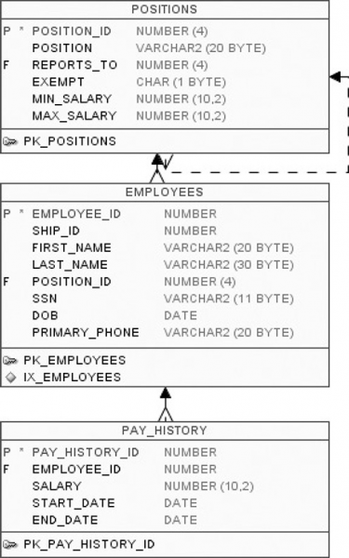

**Review the following SQL statement:**

**https://www.dbexam.com/files/dbexam/download/1Z0-071_ch8_8_A.png**

**Which of the following is true for the SQL statement?**  
(Choose two.)

**Response:**

|  |  |
| --- | --- |
| Correct | It will execute successfully. |
| Correct | It connects three tables. |
|  | It will fail because there are no table aliases. |
|  | It is an outer join. |

Score 0 of 1

**Question:**

**Which of the following can be used to remove data from a table?**  
(Choose two.)

**Response:**

|  |  |
| --- | --- |
|  | ALTER |
| Should have chosen | UPDATE |
| Wrong | MODIFY |
| Correct | DELETE |

Score 1 of 1

**Question:**

**Review the following SQL code:**

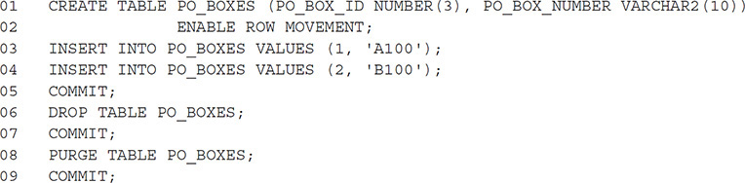

**What statement will recover the PO_BOXES table after these statements are executed?**

**Response:**

|  |  |
| --- | --- |
|  | FLASHBACK TABLE PO_BOXES TO BEFORE COMMIT; |
| Correct | None of the above—the table cannot be recovered. |
|  | FLASHBACK TABLE PO_BOXES TO TIMESTAMP SYSTIMESTAMP—INTERVAL ‘0 00:00:03’ DAY TO SECOND; |
|  | FLASHBACK TABLE PO_BOXES TO BEFORE DROP; |